May 7th, 2021
Press Release
Team Utsunomiya Kenji
“We demand cancellation of the Tokyo Olympic Games
in order to protect our lives and well-being”
Online petition to demand cancellation of the Tokyo Olympic Games
Received more than 200,000 signatures in approx. 2 days (49 hours, 23 minutes)
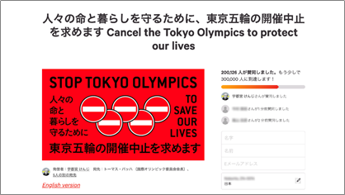
＊Download this image using the link below if necessary
https://drive.google.com/drive/u/1/folders/1HOZw5OpT5FQPv3c7TYKh_VLLYB-XoY_L

The online petition “We demand cancellation of the Tokyo Olympic Games in order to protect our lives and well-being” (http://chng.it/7tVgtCGLQ8) was founded by Utsunomiya Kenji and began at noon of May 5th, 2021. The petition reached over 200,000 signatures in the first 2 days (49hr 23min).
Change.org has announced that this petition has received signatures at the fastest rate ever recorded on its Japanese site. The record had previously been held by the campaign launched in March of 2020, which asked for the truth behind the suicide of late government official Akagi Toshio, attracting 171,000 supporters in the first three days.
As of May 7th, 2021, our petition has the third largest number of supporters, after the 381,000 supporters the campaign for Akagi Toshio had received, and the 350,000 received for the campaign launched in April of 2020, demanding the resignation of Tokyo prosecutor Kurokawa Hiromu.

Petition Outline

- Petition Title: We demand cancellation of the Tokyo Olympic Games in order to protect our lives and well-being.
- Founder: Utsunomiya Kenji
- Supporting Figures/Organizations: TBA
- Petition Destinations:
- Thomas Bach, President, International Olympic Committee
- Andrew Parsons, President, International Paralympic Committee
- Suga Yoshihide, Prime Minister
- Marukawa Tamayo, Minister, Tokyo Olympic and Paralympic Games
（丸川珠代）
- Koike Yuriko, Tokyo Governor （小池百合子）
- Hashimoto Seiko, President, Tokyo Olympic and Paralympic Games Organizing Committee（橋本聖子）
- Launch date: May 5th, 2021 (12:00 PM)
- End date: This petition campaign will continue until the decision is made to cancel the Tokyo Olympics.
- Purpose: Please refer to the petition campaign website.
- Petition Website (Change.org): http://chng.it/7tVgtCGLQ8
※ Please check the above website for the updated number of signatures.
- Petition supporters’ voices ※ with permission to publish
Please see pages 5-6
※ For updates and further announcements, please refer to the websites below or Team Utsunomiya Kenji’s Twitter page. We will be announcing the petition’s supporting figures and organizations as well as upcoming events.
★Petition information page on Utsunomiya Kenji’s official website:
https://utsunomiyakenji.jp/pressrelease-stoptokyoolympics/
May 5th (Wed) | 12:00 PM | 0hr | Petition launched
May 6th (Thu) | 12:00 PM | 24hr | 56,312 signatures
 | 7:30 PM | 31hr 30min | Reached  100,000 signatures
May 7th (Fri) | 12:00 PM | 48hr | Approx.  190,000 signatures
 | 1:23 PM | 49hr 23 min | Reached  200,000 signatures

- Statements by Utsunomiya Kenji (May 6, 2021)
We feel very encouraged by the 56,312 signatures received in the first 24 hours, calling for the cancellation of the Tokyo Olympics and Paralympics. We are planning on releasing our first report before IOC President Bach visits Japan on May 17th. We look forward to your continued support and participation.

- [Reference] Recent actions and statements made by Utsunomiya Kenji on cancelling the Tokyo Olympics

(April 17th, 2021)
“Amid the widespread outbreak of the coronavirus, 16 volunteers including those from the Community Reexamining the Kodo-ward Administration, for which I am the co-chair, and five other local groups in Koto-ward submitted the Urgent Request Form to Tokyo Governor Koike Yuriko to urge the Government, JOC, and IOC to cancel the Tokyo Olympics and Paralympics.

(May 4th, 2021)
COVID19 has threatened our lives and our economy, and the extreme delay in cancelling the Olympics not only puts additional burden but will worsen the situation we are currently in. To protest against the government’s decisions, we will be launching an online petition. We will announce its launch as soon as it is ready.

(May 5th, 2021)
We have launched an online petition calling for the cancellation of the Tokyo Olympics and Paralympics. With the rise of COVID19, we urge the IOC, the Japanese Government, the Tokyo Metropolitan Government, and the Organizing Committee to make the right decision and cancel the event as soon as possible. Please join us and sign the petition.

About Utsunomiya Kenji

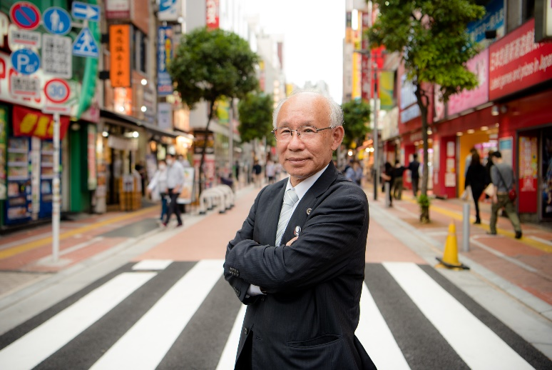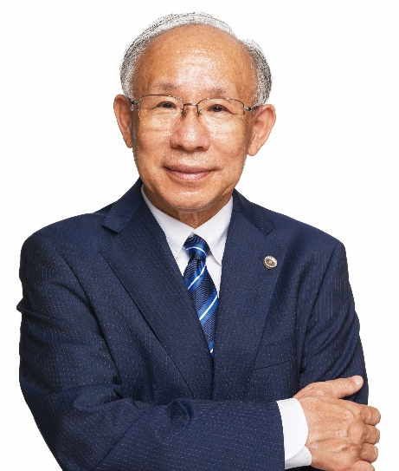
*For use of Utsunomiya Kenji’s official image, please download from the link below. https://drive.google.com/drive/u/1/folders/1HOZw5OpT5FQPv3c7TYKh_VLLYB-XoY_L

Born in 1946 in Ehime Prefecture, Utsunomiya left the University of Tokyo Law School to attend the Law Training Institute. He was registered as an attorney in 1971 and has been a member of the Tokyo Bar Association since. As a lawyer, he has been tackling issues caused by credit and loan complications, and he has been a supporter and helper of people in debt since the very beginning of his career. As the chair of the Anti-Poverty Network, he also helps amplify the voices of those who live in poverty. He served as the President of the Japan Federation of Bar Associations (JFBA) from 2010 to 2011. He is currently the head of “Toshikoshi Haken Mura (Tent City for Jobless)”.

Chair of Anti-Poverty Network; Co-chair of Community Seeking a Fair Tax System; Community Reexamining the Kodo-ward Administration; Norikonett
Director of Organization to Support Victims of the Aum Attacks
President of Utsuken School; Association Supporting Seven Eleven’s Matumoto-san
Head of Tokyo Defense Counsel Team; Defense Team to Deposit Unconstitutional Proceedings; Defense Team for Victims of Akebonobashi Training Center
Member of COVID19 Disaster Emergency Action; Metropolitan Government Oversight Committee

- Official Website https://utsunomiyakenji.jp/
- Twitter https://twitter.com/utsunomiyakenji/
- Instagram https://www.instagram.com/utsunomiya_kenji/
- TikTok https://www.tiktok.com/@teamkenjiutsunomiya

【Contact】
Kinoshita at Team Utsunomiya Kenji
utsukenstaff@gmail.com or https://utsunomiyakenji.jp/press/
For reference
Petition supporters’ voices in Japan
Below are comments received from those who signed the petition in Japan.
(English translation)

- 「もう、医療は崩壊しているのに、オリンピックをやる意味がわからない。」（看護師）
- “I do not understand the reason to hold the Olympics when our medical care system is already in a state of collapse” (Nurse)
- 「国民のコロナ感染者の入院できる施設もベッドも足りない国がオリンピックなんてできるはずがないです。」
- “It’s impossible to host the Olympics in a country where not enough facilities and hospital beds can be provided even for domestic citizens.”
- 「国民の犠牲の上で開かれる祭典になります 早く目を覚まして欲しい」
- “The event will be held at the expense of the citizens’ health. The government must wake up.”
- 「政府はオリンピック遂行のためにコロナ対応をサボってきた。怒！」
- “The government has responded so loosely to the pandemic, solely to be able to host the Olympics as planned. I’m in rage!”
- 「IOCも無責任すぎる。スポーツ選手には可哀想だがもっと可哀想な人はたくさんいるのが現状。」
- “The IOC is being extremely irresponsible. As much as I feel sorry for the athletes, there are others who I feel more sorry for.”
- 「人命を大切と思うなら、国民の過半のワクチン接種がすむまではオリンピックを開催すべきではない。ワクチン接種率が先進国最低となった失政のつけを国民の命であがなうべきではない。」
- “If the government cares for human life at all, they must wait to host the Olympics until the majority of the population is vaccinated. The government should not expect the public to tolerate the fact that we have the lowest vaccination rate of any developed country.”
- 「オリンピック中止こそ最大のコロナ対策」
- “Canceling the Olympics would be the biggest COVID19 safety protocol.”

- 「オリンピックで日本がメチャクチャになるのを見たくありません！」
- “I don’t want to see the Olympics worsen the situation that Japan is currently in!”

- 「子供達の遊び場も無い、自由に外に出られない、札幌市は小中学生の修学旅行さえ延期となった。そこまで我慢させてるんだぞ。うちの子（小学六年）は涙目で『5、6年生になって思い出が何も無い』と言った。そんな中でオリンピックを見ても楽しむことは自分はできない。 一部の富裕層やスポンサーに利益になるからと言って、一般の人や、ましてや子供に我慢させて、何が平和の祭典だ」
- “Children can’t play in the playgrounds, and can’t even go outside freely - Sapporo’s elementary and middle schools were stripped from their annual graduations trips. My 6th grade child told me with tearful eyes, ‘I don’t have any good memories from 5th and 6th grade.’ I can’t possibly enjoy watching the Olympics when put in a situation like this. Why call the Olympics a ‘celebration of peace’ when only the wealthy would benefit from this, not the majority, nor our children.”

- 「市民には自粛を強いておいて、外国からは人を大勢入れるのか？ 民間のイベントは中止、でも五輪は別です。そう考えているのはアホな政府だけです。 協力金の支払いも全く追い付いていないのに、居酒屋を目の敵にして休業に追い込み、アウトドアでも感染するので外でも飲むな！ でも五輪のテスト大会はやります。 こんな筋の通らんことをされて誰が自粛するのか？ 」
- “While people in Japan are asked to refrain from leisurely activities, countless foreigners are allowed to come to the country? Olympics are allowed when all other events in Japan are cancelled? Only a stupid government would think with such logic - subsidies aren’t being given out efficiently, and you expect small businesses to stay closed while you prepare for the Olympics? Who will listen to you, the government, when everything is so illogical?

- 「安倍氏の「アンダーコントロール」誘致演説に始まり、「復興五輪」「人類がコロナに打ち勝った証としての東京五輪」…と嘘に嘘を重ねてきたこと自体けしからん話ですが、このままでは「コロナ医療崩壊を加速させる東京五輪」になりかねない危険な状況です。そもそも長期間振り回され続けているオリパラ・アスリートの皆さんが気の毒でなりません。」
- ”We’ve been told lies after lies - from Abe’s speech to promote the Olympics where he said everything was ‘under-control’, to the government claiming that the Olympics will be a symbol of recovery. But, it is likely that it will simply be recognized as the Olympics that accelerated the spread of the virus. I feel bad for the Olympic and Paralympic athletes that are being tossed around.

